**AMITY GLOBAL BUSINESS SCHOOL, PUNE**

**AMITY UNIVERSITY**



A

**SUMMER INTERNSHIP**

ON

**“ Marketing of Portfolio Management Services at Agile Capital Services ”**

Submitted by:

**Arya Rajendra Athare**

ENROLLMENT NO:A31501921065

Course: MBA 2nd Semester

BATCH 2021- 2023

UNDER THE GUIDANCE OF

**Dr. Nitu Saxena**

SUBMITTED IN THE PARTIAL FULFILMENT OF

THE REQUIREMENTS FOR THE DEGREE OF

MASTER OF BUSINESS ADMINISTRATION (MBA)

DECLARATION

Title of Summer internship

**“ Marketing of Portfolio Management Services at Agile Capital Services ”**

“ I declare

(a) That the work presented for assessment in this summer internship Report is my own, that it has not previously been presented for another assessment and that my debts (for words, data, arguments and ideas) have been appropriately acknowledged.

(b) That the work conforms to the guidelines for presentation and style set out in the relevant documentation.

(c) The plagiarism in the report is ___________ % ( permissible limit is 15 % )

Date: 6th October 2022

Name of student- Arya Athare

Enrollment No _A31501921065

` MBA – specialization :Marketing and IT ( Batch 2021- 23 )

CERTIFICATE OF COMPLETION

**Amity Global Business School , Pune**

This is to certify that the project work title

**“ Marketing of Portfolio Management Services at Agile Capital Services ”**

Is a bonafide work that is done by

ARYA RAJENDRA ATHARE

Enrolment No. A31501921065

For the award degree of

**MASTER OF BUSINESS ADMINISTRATION**



Col. (Dr.) Sneh. V. Sharma Dr. Nitu Saxena

DIRECTOR GENERAL FACULTY GUIDE

FACULTY GUIDE CERTIFICATE

**Amity Global Business School, Pune**

This is to certify that Arya Athare ,student of MBA – specialization Marketing & IT, at Amity Global Business School, Pune has completed the summer internship Report on_**“ Marketing of Portfolio Management Services at Agile Capital Services ”**

The report has been checked for plagiarism and is within the limits of acceptance.

Name of Guide - Dr.Nitu Saxena

Designation :Associate Professor

AGBS Pune

**INDUSTRY GUIDE CERTIFICATE**

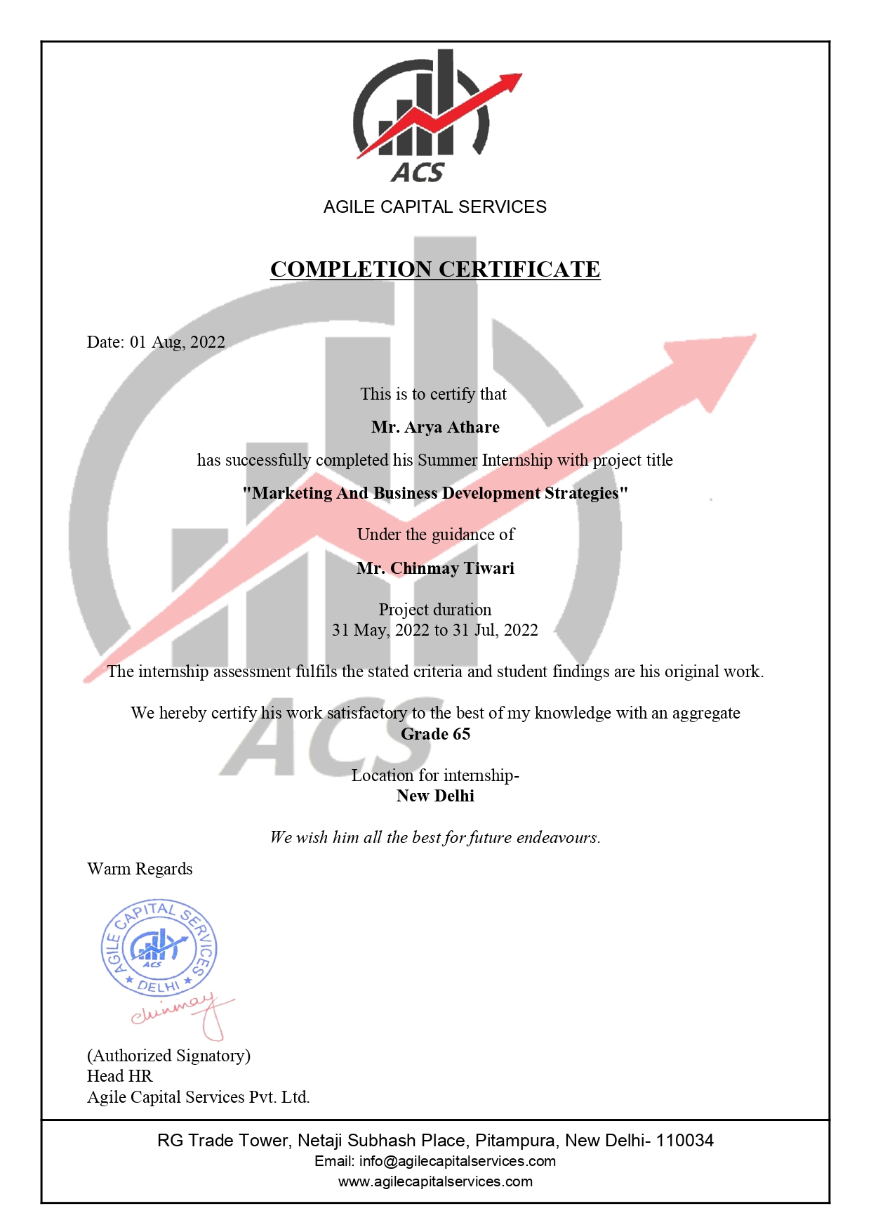

**ACKNOWLEDGMENT**

No task is a single person's effort , the same is with my summer internship project .Thus , I would like to extend my sincere thanks to all those who have helped me to accomplish my project .

With a deep sense of pleasure and satisfaction I have completed this project on **“ Marketing of Portfolio Management Services at Agile Capital Services ”** and thereby take the opportunity to thank Chinmay Tiwari and Himalay Sethi for entrusting and to assist me for this 2 months of internship . I also extend my heartiest thanks to Col. (Dr.) Sneh. V. Sharma , DIRECTOR GENERAL AGBS ,PUNE for giving us the scope for this wonderful internship period . I also express my genuine gratitude towards Dr. Nitu Saxena for being a supportive and motivational faculty guide for my SIP. Last but not the least, I thank all the faculty members of AMITY, my friends as well as my family for their support and guidance .

**ABSTRACT**

I, Arya Athare , completed my summer internship and prepared the following project titled .**“ Marketing of Portfolio Management Services at Agile Capital Services ”**

executed at BFSI Agile capital services Pvt.Ltd, 1208, 12th floor, RG Trade Tower, Netaji Subhash Place, Pitampura, New Delhi-110034. This project was aimed at marketing and promoting the products and services provided by Agile capital services Pvt.Ltd. The product promoted was an investment opportunity in the insurance product of India's first life insurance company associated with Agile Capital Services Pvt.Ltd. This included a baseline study of the BFSI sector industry, a swot analysis of the company and a research study on customer attitudes and expectations towards insurance products and services.

The following project required visiting potential customers in the target segment of my contacts in Pune. Primary and secondary data sources were used for the internship project, which included a primary survey conducted by preparing a questionnaire in order to analyze their perception of insurance products and services, their expectations, risk appetite, preferences when choosing an insurance company. The study showed that customers expect a seamless transaction experience and easy, risk-free returns along with certain tax benefits. Most customers do not see insurance as a long-term investment opportunity, and the main factors that lead customers to buy a brand policy are its customer service, reputation and price. This project involved pitching the product to approximately 50 potential customers and generating leads to become customers of the company. A special feature was the correlation of marketing concepts according to situations and their implementation in real life, and the performance of a ratio analysis of the BFSI company and comparison of its changes. This has helped to create value for learning business techniques and behaviors. Overall, it was a great opportunity to put knowledge and skills into practice in both real life and company life.

**TABLE OF CONTENTS**

|  |  |  |
| --- | --- | --- |
| S.NO | Contents | Page No. |
| 1 | INTRODUCTION | 9-18 |
| 2 | RESEARCH OBJECTIVES | 19 |
| 3 | SCOPE | 20 |
| 4 | LIMITATION | 21 |
| 5 | RESEARCH METHODOLOGY | 22 |
| 6 | DATA ANALYSIS AND INTERPRETATION | 23-31 |
| 7 | FINDINGS | 31-33 |
| 8 | OBSERVATION | 34 |
| 9 | RECOMMENDATIONS | 35 |
| 10 | CONCLUSION | 36 |
| 11 | BIBLIOGRAPHY | 37 |
| 12 | Annexure | 38 |

**INTRODUCTION**

**About Company**

ACS is the choice of many renowned multinational organizations and enterprises due to their commitment to deliver the best results. ACS prides itself on its reputation as a trusted and reliable talent acquisition partner by providing there clients with the expert guidance to achieve financial independence.

The company has experts who provide consultancy services for financial management and investments to an individual so that they can secure their financial future themselves/ family . Providing professional and expert advice in wealth maximization, career planning and exploring between the job seeker and talent seeker.The experts provide financial advice in the simplest way possible because companies believe in managing wealth in a less complicated way.

Agile Capital Services is one of the emerging consulting firms in India. At Agile Capital, they provide wealth management services to High and Ultra High Net Worth Individuals (Hnis & Uhnis).

Their highly trained and specialized team engages with clients from across the country as those based abroad. in addition to our custom-designed solutions, they focus on 'un complicating' the entire process of investment for each client. The focus on building long-term relationships defines business. There advisory backed by a strong product and research team, underscores the unmatched value of the ACS proposition.

**Services at ACS are :**

1. Consulting Services :

**“As a niche expert financial services consulting firm, we have precise deep and broad skillfulness and only employee consultants who share the same credentials.”**

1. **Portfolio Services :**

"The process of managing an individual's investments to maximize their gains over a given time horizon."

3-Recruitment Services:

"Nothing is more important than hiring and developing people because getting the right talent is the key to any organization's growth."

4-Financial services:

"Financial statement analysis brings the method of determining significant operating and financial characteristics from accounting data to gain insight into the operations of a business."

5-Tax services:

"Taxation represents probably the most ever-changing and complex challenge in the context of financial planning."

**Vision :**

The vision is to importantly increase the wealth of the clients by supplying the best financial services while being the most precious recruitment service provider.

**Mission:**

They strive to supply the highest-grade and easiest wealth management advice with honest financial solutions and also inspire candidates to look into career opportunities in across industries.

The company has about 50 employees all over India. The managing director and each branch is operated by a branch manager under which their are regional sales managers. It also has a HR manager and an assistant HR manager for every branch.

The financial services ,banking and insurance (BFSI) sector plays an important role in providing a wide extent of financial products and services. All banks and financial institutions that provide financial services or companies that are in one or more of these financial sectors have this. BFSIs include commercial banks, insurance companies, cooperatives of non-banking financial companies, pension funds, mutual funds and other smaller financial entities.

The banking segment at BFSI includes core banking, retail banking, private, corporate, investment and cards. Financial services include stock brokerage, payment gateways, mutual funds. Insurance includes both life insurance and general insurance. As of September 2019, the Indian banking system consists of 18 public sector banks, 22 private sector banks, 46 foreign banks, 53 regional rural banks, 1,542 urban cooperative banks and 94,384 rural cooperative banks. The banks of Public Sector for 61.21% of total banking sector assets in FY19. In fiscal year 2019, total assets in the public and private banking sectors were $1,422.97 billion and $741.79 billion, respectively. India is also the fastest growing fintech market in the world. In the world, it ranks highest in terms of adoption, along with China. In India, insurance market has also seen important growth over the past 8 years. The Indian insurance market had a total gross written premium of USD 96.9 billion in 2017, representing a compound annual growth rate (CAGR) of 12.3% between 2013 and 2017. The market CAGR during 2017-22 is approximation to be 4.9%. India accounts for 6.1% of the worth of the Asia Pacific insurance market.

According to the Business Maps of India website, the growth of the BFSI sector is 8.5% per annum. According to a SIAM report published in 2019 (SIAM, 2019), domestic sales are growing at 20% in the last 2 years and according to global website, the BFSI sector in India is set to grow exponentially due to rising per capita income, new product launches, innovation in technology, expanding distribution , networking and increasing customer awareness of financial products.

This sector contributes about 7.7% of the total GDP in India according to wikieducator.org. In FY21, India received the highest ever total foreign direct investment (FDI) inflow of US$81.72 billion, up 10% from 2019–20. 100% FDI allowed under automatic route. The digital payments market is expected to reach $1 trillion by 2023, according to the FDI financing website. The BFSI sector in India is valued at Rs. 81 trillion and is liable to become the fifth largest in the world by 2020 and third largest by 2025.

**Investment Opportunities :**

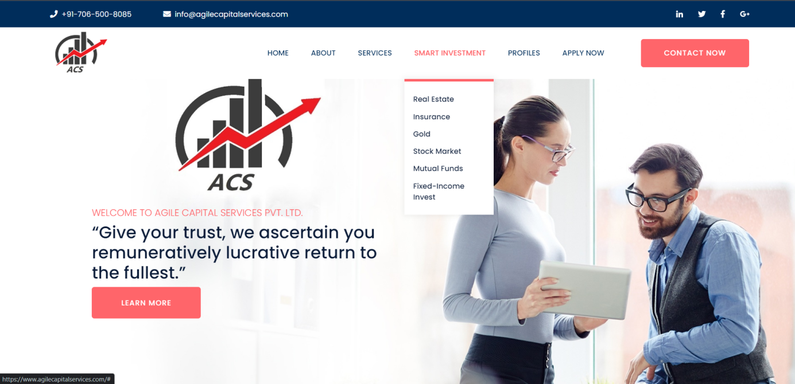

The home page of Agile Capital Services provides us with various smart investment opportunities . Such as :

1. Real Estate

Real estate can be simply defined as land along with any permanent development attached to the land, whether natural or man-made – including water, trees, minerals, buildings, houses and bridges. Real estate is a form of real estate.

1. Insurance

Insurance is a sort of risk management in which the insured transfers the cost of a potential loss to another entity in exchange for a monetary compensation known as the premium. It is an arrangement whereby a company or state guarantees compensation for a specified loss, damage, illness or death in exchange for the payment of a specified premium. Insurance helps eliminate worry, provides tax benefits and, most importantly, is available to almost everyone.

1. Gold

It is indestructible, relatively rare, and cannot be crafted. It is the best and most refreshing alternative to the complex investment products that are in the headlines today and is easy to buy and sell. In fact, gold is so simple that it is used as a global currency in today's world that can be traded all over the world.

1. Stock Market

The stock market refers to the collection of markets and exchanges where regular activities of buying, selling, and issuance of shares of publicly-held companies take place.

1. Mutual Funds

A mutual fund is a type of investment vehicle consisting of a portfolio of stocks, bonds or other securities. Mutual funds provide small or individual investors with access to diversified, professionally managed portfolios at a low cost. Mutual funds are divided into several types of categories that represent the types of securities they invest in, their investment objectives, and the type of returns they seek. The vast majority of money from employer-sponsored pension plans goes into mutual funds.

1. Fixed Income Invest

Seek to generate income by investing in bonds and fixed income securities, which means these funds buy bonds and earn interest income on the investments.

The term investment is known as "giving something up now for the prospect of getting something back later."

At ACS, they clients many smart investment options.

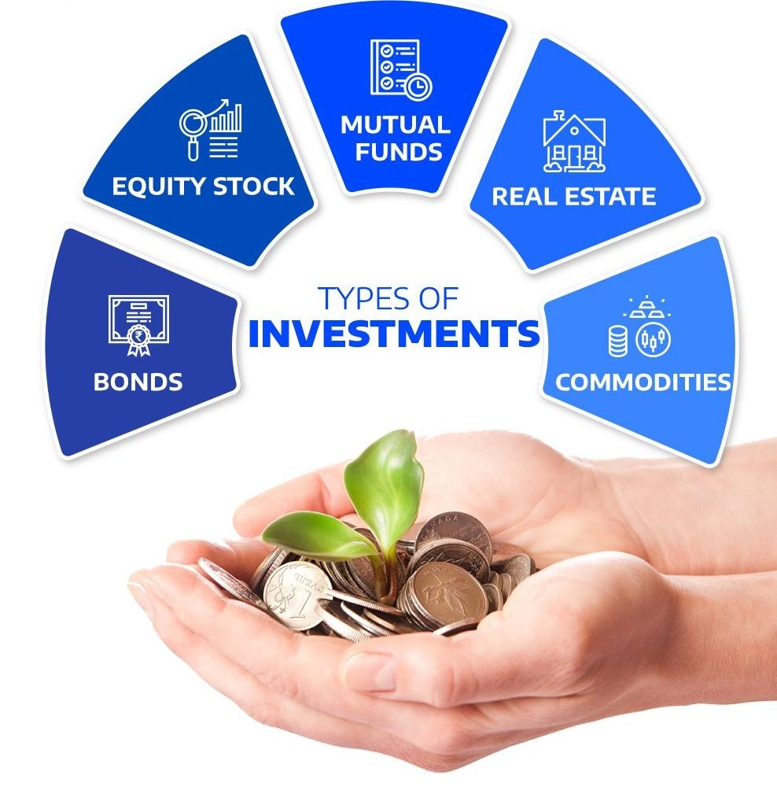

**Major Players-**

In the Industry , major players in banking are HDFC Bank Ltd, ICICI Bank Ltd, State Bank of India. Major companies in financial services are Bajaj Finance Limited, Tata Capital Financial Services Ltd, Aditya Birla Finance Ltd. In insurance, Life Insurance Corporation of India, Max Life Insurance Company, HDFC Life Insurance Company are the top companies in the Indian market.

**Porter's Five Forces-**

• Threats (new entrants ) –

The threat of new entrants from within the financial industry is relatively small. It is not common for a new company to enter the market and try to compete on the same level as the big companies. New competitors would face a number of significant barriers, the capital and time needed to develop an important brand identity.

• Suppliers Bargaining Power –

A financial services company has two main suppliers. The first group belongs of depositors who supply the primary source of capital, the second is his employees, also known as the source of labor. The threat from individual depositors is minimum, as is the bargaining power of consumers.

• Buyers' Bargaining Power –

The BFSI sector relies to a great extent on the bargaining power of consumers. Some got more power than others.

• Threat of Substitutes –

The threat of substitute products has exaggerated in the investment banking industry as companies outside the industry have begun to offer differentiated financial services that were traditionally only available from banks.

• Competition –

Competition in the financial industry is likely the strongest from Porter's model. The company not only comes across big competition from other large banks and money center financial institutions such as Bajaj, which funds Limited Financial Services and TATA Capital Financial Services in India.

**Business model of the company –**

The B2C model of Agile Capital Services, where businesses sell to their end users. Because this business model is based on transactions between a company that sells products or services to an individual customer, are the end users of those services. Provides services to end customers

**SWOT-**

**STRENGTHS -**

A. Services

One of the main advantages of Agile is its after-sales services. Agile has a team of dedicated executives who guide and advise their clients to the best of their knowledge. Account holders can trade over the phone or even online. Agile sends investors their account progress every month, so investors can sit back, relax and watch their money grow.

b. Distribution network

Agile Capital Services has more than 8,000 clients to whom they provide wealth management services across India. It can be in person or online. A specialized team and highly trained people work with clients worldwide .

Hassle-free process – in addition to their own custom-designed solutions, they focus on “uncomplicating” the entire investment process for each client, whether online or offline.

C. Products

ACS services product line is quite flexible where every customers needs are satisfied in consideration of the risk appetite. Every product covers the gaps of every other product offered by other competitors, such as low cost, best returns , easy to track transactions etc.

**WEAKNESS -**

A. Customer satisfaction

Agile needs to work its socks off when it comes to customer satisfaction. Many brokerage firms that cater to large investors or a niche segment of the market can provide their clients with bank advisors who can deal with the business needs of a variety of clients and suggest/provide accordingly.

b. Branding

The company might have an impressive product, but most of the investing population is unfamiliar with it. One of the basic expectations of a trader when he starts investing is that he must get well-timed deliveries of shares . The balance of cash with the partner must also be safe. Although trust in the company comes along with time and experience, good and transparency also plays a vital role in instilling trust in traders.

C. Competition from Other Players

Some huge players like Bajaj Finance Limited. Tata Capital Financial Services Ltd. Aditya Birla Finance Ltd. L & T Finance Limited. Being an old player gives customers confidence as they have been in the market for around a decade. Agile Capital Services is really a new company to many customers, so it has to out-compete its competitors.

**OPPORTUNITIES**

With the help of exact analysis of the external environment, one can get great new opportunities and growth .

A. Market Growth

Many investors who are capable enough to take benefit from the advisory service opportunities. Agile just needs to identify and target these customers. It is known for its Wealth Management Services for Ultra High Net Worth Individuals. He was dynamic enough to diversify the client's investment portfolio to reduce risk and maximize returns.

b. Improvement of technology

In a country like India, technology is constantly improving, which gives exposure to the company and a chance to continuously improve its product, while niche players like locals will find it difficult to sustain with the changing technology. With SEBI, RBI and IRDA (SEBI). IRDAI: Due to some strict rules by the Insurance Regulatory and Document Authority, it is more difficult for local companies to retain customers without a research team and no funding source. . The dependency of traditional business is such that which depends on sub brokers and networking where there is lack of technology .

C. Unfulfilled customer needs

With a huge competition offering their products in the market, no one can stand to satisfy the needs of the customer . Some have a problem with a lack of info or some are afraid of the unpredictability of stock markets. Agile has a chance to take advantage of this disaffected customer group and gain a foothold in the market. The Internet breaks all information barriers because it offers an extremely hassle-free investment platform.

d. Increasing the level of education

Year by year, the education level is increasing in the country when it comes to technology. With this, the knowledge of investing in portfolios and their management is also increasing, and many small investors are penetrating the markets, which is reflected in increasing volumes of transactions.

**THREATS**

A. Existing Competitors

Many existing companies that have the experience and the trust of people of the country for their financial services. In this competitive scenario, it is difficult for new companies to gain the trust of the customers and to gain a proper customer base. However, there is a chance to achieve this with the experience and good services that the company gives to its customers.

**RESEARCH OBJECTIVE**

* Analysis of Agile Capital Services w.r.t Porter’s Five Forces
* SWOT analysis of company
* Research on attitude and expectations of potential customers on insurance products

**SCOPE**

The scope of the current phase of the project is limited to promoting and presenting the insurance product of India first life Guaranteed Benefit Plan and understanding the attitude and expectations of potential customers.

As part of the internship, the job allows you to do marketing and sales for the company, generate potential customers for the company, convince them and convert them into real customers. The product is India's first life Maha Jeevan plus and India's first life guaranteed benefit plan promoted by Bank of Baroda and Union bank of India. The motive behind this SIP was to promote and bring in new customers for the company. Through available contacts and mutual contacts, approached potential customers also for the purpose of presenting and promoting the product and its benefits.

The target market was employees and entrepreneurs between the ages of 21 and 60. Furthermore, those interested in saving and investing in fixed deposits, insurance. Potential customers were asked a set of questions for a research study on customer attitudes and expectations, both directly and via an online questionnaire.

**LIMITATIONS**

There are few limitations ;

1. Time frame

A. As the time set for SIP is only eight weeks, it is difficult to analyze the needs of the target segment to further develop and sell the service using traditional and new media.

2. Information crisis:

A. Because there is no out-of-the-box documentation for Agile capital services. , it difficult to browse the web and grab the necessary data, but again, confidential information regarding the organization is not available.

b. Other organizations are not ready to share information related to their marketing strategies. This is useful for developing and understanding the strategies companies use to help agile capital services.

3. Geographical restriction is one of them.

4. The penetration study at the brand level is limited because the project deals with only a few products and not the whole range of products available.

**RESEARCH METHODOLOGY**

Research method is defined as the tools or instruments used to accomplish the goals and attributes for the study .Research begins with asking appropriate questions and proper understanding of the topic/task to be completed .

My research includes :

1- Primary Data

Data /information/observations are collected from the targeted sample .

2- Secondary Data

Use of various authentic websites , articles, news for research purposes .

* Qualitative research :-

Qualitative research is about inquiry . It helps create an in - depth understanding of problems or issues in their natural settings .This is a non-statistical method which I have used for my overall research and report .

The following are the methods used for research :

1- One on One discussions

* Quantitative research :-

Quantitative research is a structured way of collecting data and analyzing it to draw conclusions .This method uses the statistical method to analyze the data and also considers the numbers .

The following are the methods used for research :

1. Questionnaire

* Exploratory Research

**DATA & INTERPRETATION**

The study is supported by customer attitudes and expectations towards products(insurance) and services. The research design used in this report is exploratory, followed by descriptive research design as the report attempts to describe and explain the conditions using questionnaires to fully describe the study. This survey is channelled through a questionnaire with approximately 104 responses from random insurance customers. For the necessity of the study , 104 customers were randomly selected and their views on various parameters from which 4-5 customers were positive lead to purchasing the insurance plan. Data is gathered by directly asking some questions related to their earnings and investments through one-on-one discussion and recording them through online Google forms.

Data Collection Tools –

This project is more exploratory research with more qualitative than quantitative analysis. The data accumulation process for this project begins with finding a sample population. . A questionnaire was prepared and the collection of data was done through direct and telephone interaction and the communication method was formal.

**Analysis of data from the Questionnaire –**

1**-**The below given table is about the age groups of the respondents of this study in which the majority (44.2%) is from the 25-40 age category.

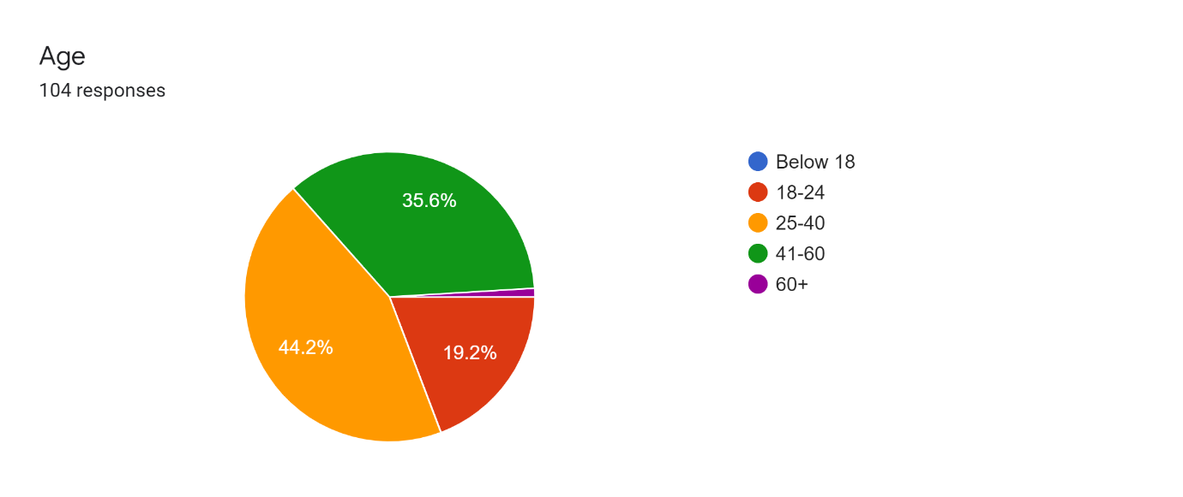

**Table-1 Age of the customers**

|  |  |  |
| --- | --- | --- |
| **Options** | **No. of respondents** | **Percentage** |
| **Below 18** | **0** | **0** |
| **18-24** | **20** | **19.2** |
| **25-40** | **37** | **35.6** |
| **41-60** | **46** | **44.2** |
| **60+** | **1** | **0.96** |
| **Total** | **104** | **100** |

Source – Primary data

2 - 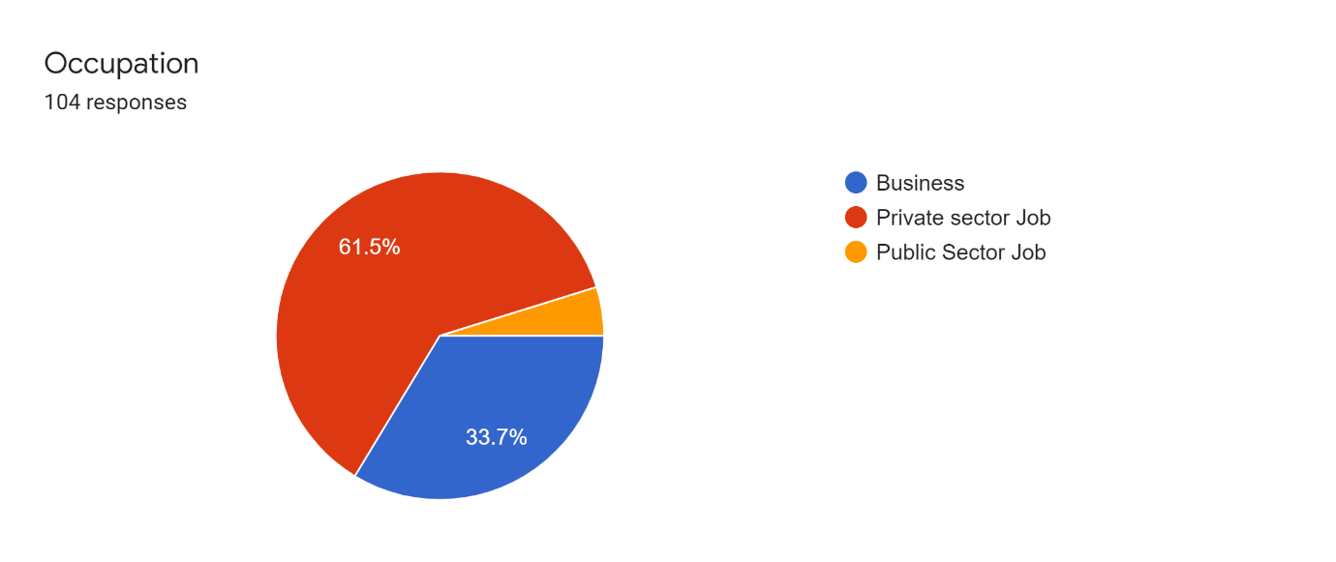

**Interpretation** - As we can see from the above pie chart about the different occupations of the customers, where the majority (61.5%) is from private sector job and the next highest (33.7%) is of business and the remaining (4.8%) is public sector.

3-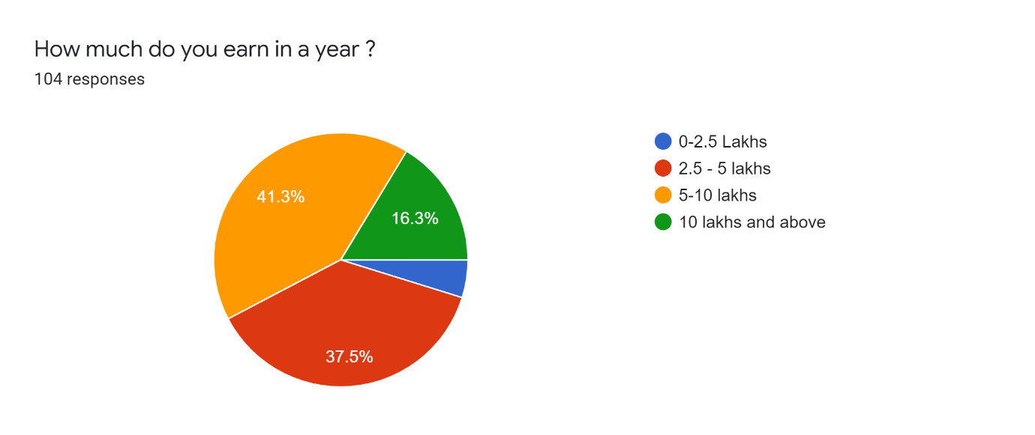

**Interpretation -** When asked about the earnings of the respondents, more 41.3% people earn between 5-10 lakh and the least is 0-2.5 lakh with 4.9%.

4-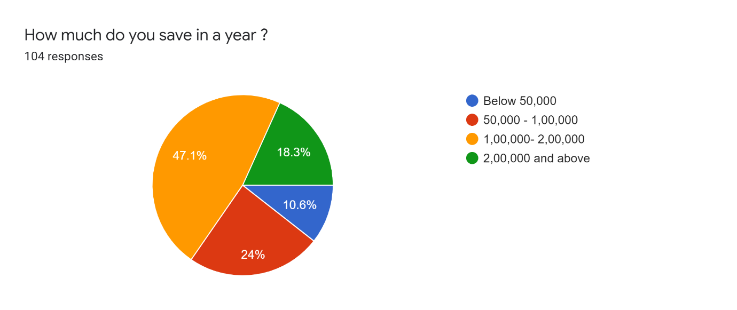

**Interpretation -**It can be observed from the pie chart that about 47.1% of respondents save up to 1,00,000 – 2,00,000 rupees annually, 24% save 50,000 – 1,00,000, 18.3% save more than 2 lakh and least is 10.6% for those below 50,000.

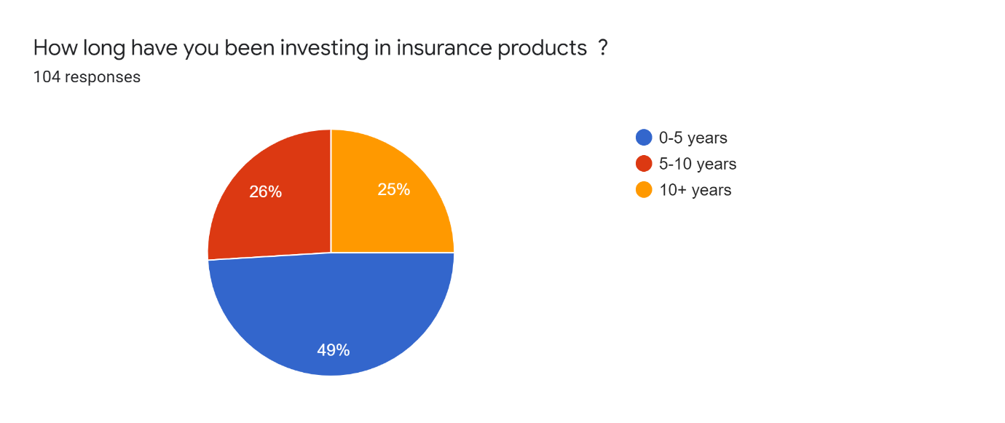

**Interpretation -** Since the respondents are all customers of insurance products, they were asked about their investment time period in insurance products. It is observed that 49% of people have been investing for 0-5 years, 26% are from 5-10 years and 25% are more than 10+ years.

**6-**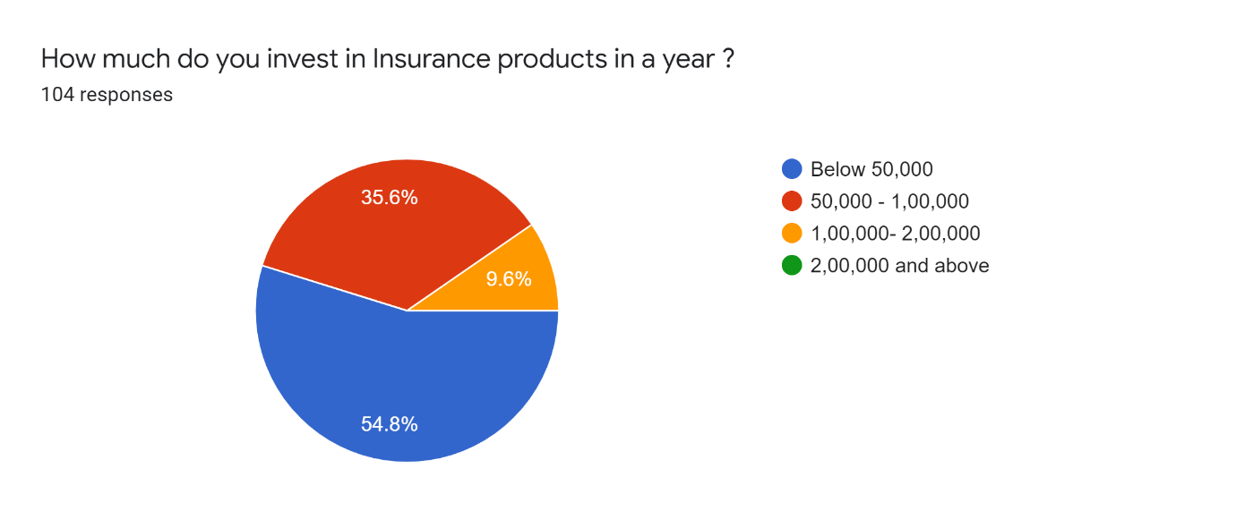

**Interpretation -** The above given pie chart is about the questions associated with the investments of customers in insurance products. Here, more than 50%(54.8)are investing below 50,000 rupees in insurance products, which says how much they are interested in investing based on their savings, as its also recorded in other questions.

**7-**

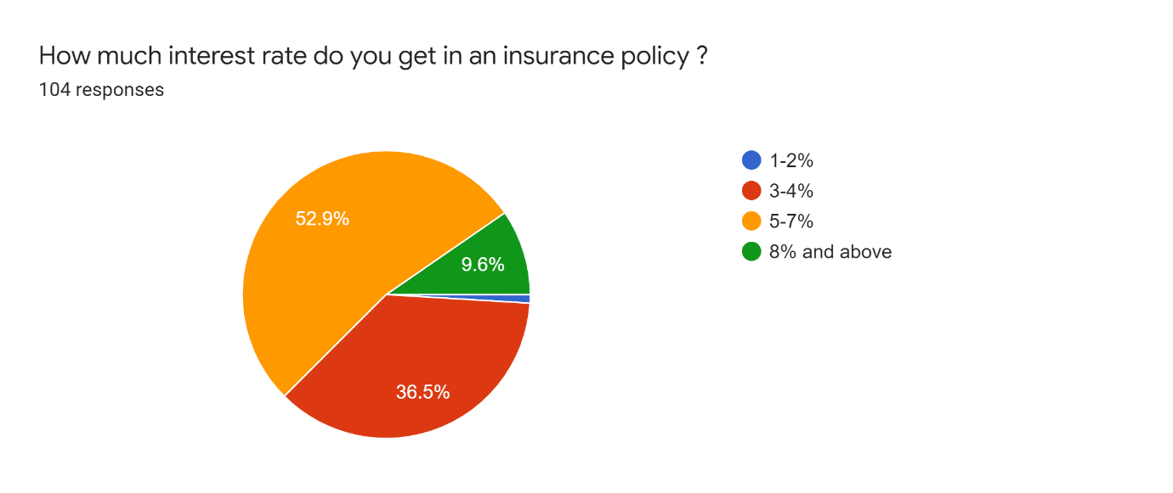

**Interpretation -**When asked about how much interest rate they get on their insurance policy, it has been observed that 52.9% of people get 5-7% of the interest rate on their policies and 36.5% of people get 3-4%, 9.6% of respondents get more than 8%.

8-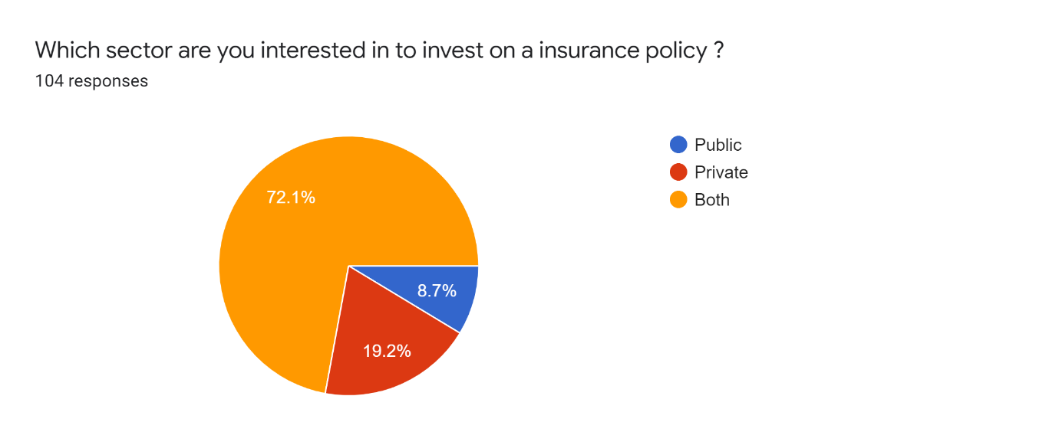

**Interpretation -** The target respondents were asked about their preference ,what sector they prefer to take an insurance policy. Majority (72.1%) people were interested in both public and private sector companies and the other 19.2% were in private only and 8.7% were in public only.

9-

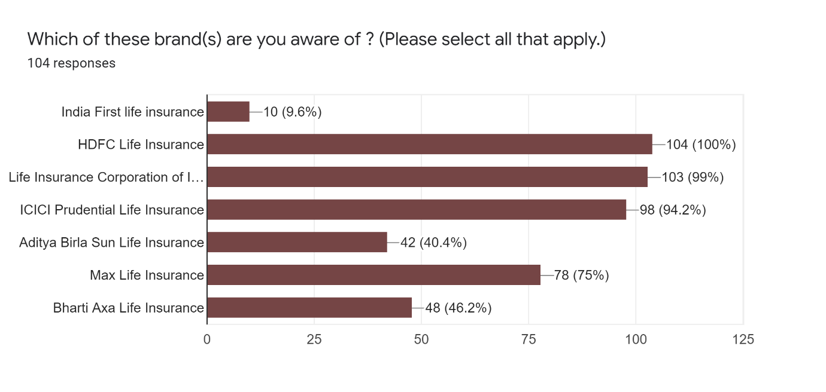

**Interpretation -**In-order to know about the brand awareness in insurance companies, when asked to select which ever brands the customers are aware of, Both LIC and HDFC life were 100% known to the respondents and the next was ICICI with 94.2% , Max Life Insurance with 75%, Aditya Birla Sun Life insurance with 40.4%, Bharti Axa Life Insurance 46.2% and the least was India First Life Insurance with 9.6%.

**10-**

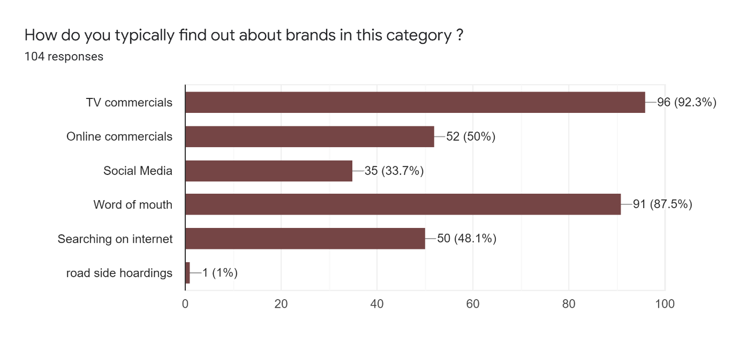

**Interpretation -** Here, it is questioned about how they find these brands or any other insurance company brands in the market 92.3% found through TV commercials and other segments like online commercials with 50%, word of mouth of 87.5% simultaneously. It could be possible that some of them found through all other modes of communications.

11-

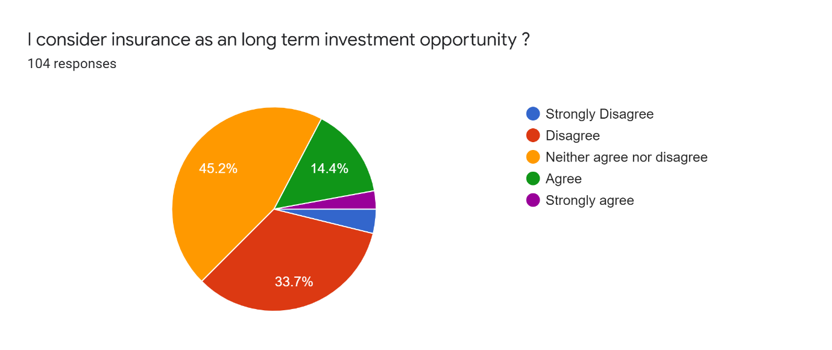

**Interpretation-** Here, the respondents have been asked to show their agreement on the statement given in the pie chart above 45.2% neither agree nor disagree with the statement to consider insurance as a long-term investment opportunity and 33.7% disagree with the given statement. And 14.4% of people agree with the statement.

12-

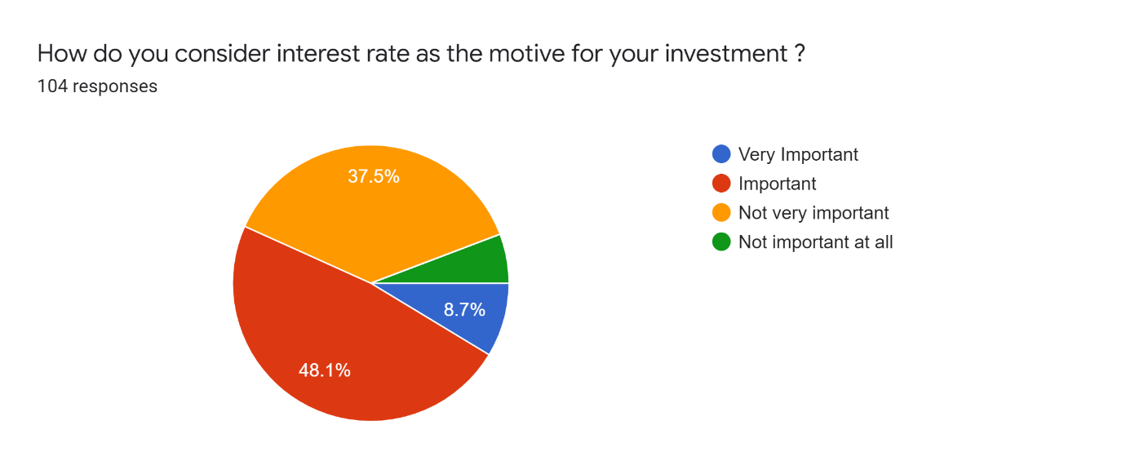

**Interpretation-** When questioned about the customers' perception of the interest rate as the main motive of their investment, 48.1% said that the interest rate was the reason for their investment and 37.5% think that it is not very important and 8.7% of people think that it is very important.

13-

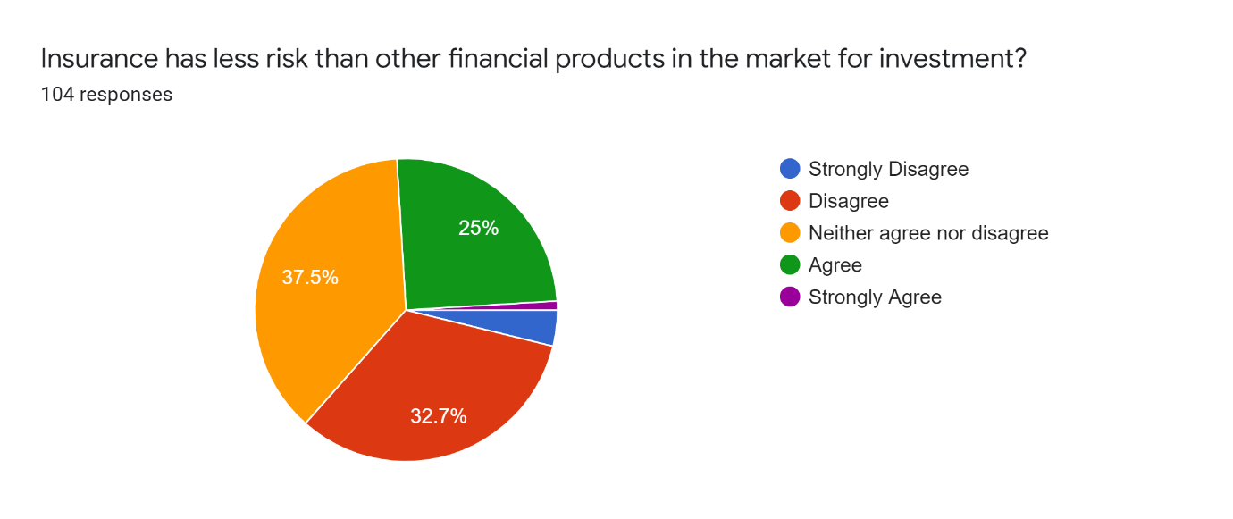

**Interpretation-** When questioned about whether insurance has less risk than other financial products in the market for investment, 37.5 % were not sure and 32.7% disagreed with the statement and 25% agreed to that statement.

**14-**

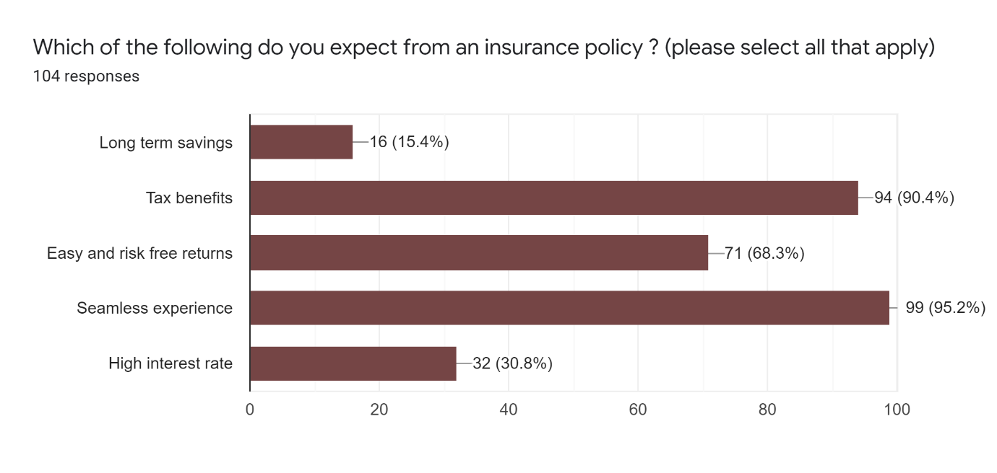

**Interpretation -** Here, it was questioned about the expectations of the customers from an insurance policy where they can select multiple choices on their expectations . It shows that 99% of respondents are expecting a seamless experience in their insurance policies. Next highest is tax benefits and easy, risk-free returns, with 94% and 71% respectively. It is surprising to see the high interest rate is only 30.8% and long term savings is 15.4%.

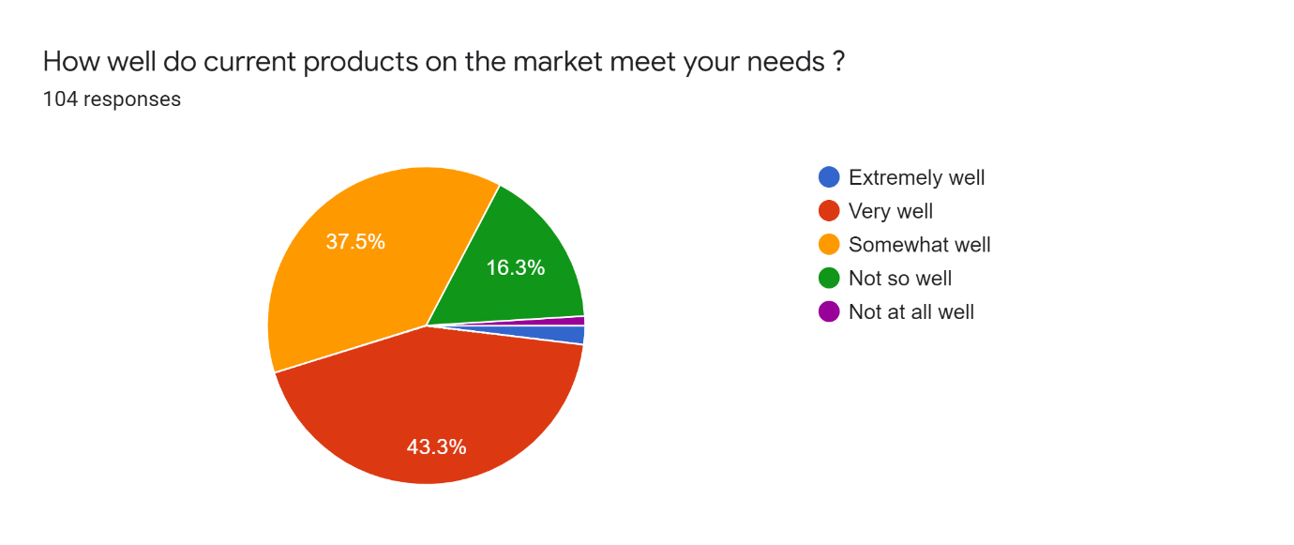

**Interpretation -** When asked about the market, customer expectations match or not whether their needs are satisfied properly or not. 43.3% said very well and 37.5% with somewhat well, and 16.3% of not so well.

1. 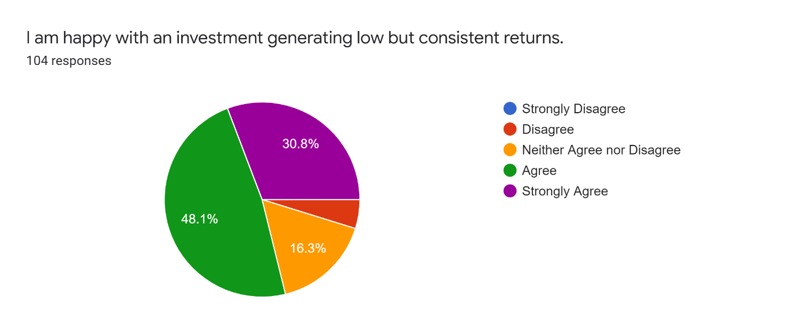

**Interpretation -** From the above data, it is interpreted that 82 respondents (48.1%+30.8%) makes investment in order to generate consistent returns irrespective of the amount of the returns. 22 respondents are not expecting consistent returns, they are ready to wait to receive the returns.

**FINDINGS**

|  |  |  |
| --- | --- | --- |
| **S.No.** | **Objectives** | **Findings** |
| 1. | To learn how many customers invest in insurance products out of their savings. | It is seen that 57 members (54.8%) invest below 50,000 and 37 members (35.6%) invest between 50,000-1,00,000 rupees. |
| 2. | To find out which sector the customers are more interested in. | It was seen that 75 members (72.1%) out of 104 are interested in both sectors and 20(19.2%) were interested in private, and 9(8.7%) members in public only. |
| 3. | To understand the brand perception of customers on insurance companies. (Select the brands which they are familiar with) | When asked to select which companies they are familiar to, HDFC and LIC are on top with 100% recognition of their brand name followed by ICICI and max life insurance. It says how important a brand image is to the insurance companies to be recognized by the customers. |
| 4. | To understand the medium of brand recognition. | The respondents were questioned to select what they found about these particular brands. In this, TV commercials are the highest rated with 92 respondents finding insurance companies through it. The next is followed by word of mouth (91 members), which is also one of the marketing tricks to grab brand recognition in the market. |
| 5. | To find the factors important to making the decision to purchase a brand. | It is seen that customer service has members selected as the major factor to decide whether the company buy insurance, followed by price and company reputation, selected by 86 and 85 members respectively. |
| 6. | To understand whether insurance is a long-term investment opportunity or not. | The survey shows that 47(45.2%) were unsure whether it was or not, but 35 members (33.7%) think that insurance is not a long-term investment opportunity. But, 15 members (14.4%) believe that it could be a long-term opportunity. |
| 7. | To find out whether insurance is considered less risk than other financial products in the market. | The results showed that 39(37.5%) were unsure about the statement, but 34 members (32.7%) think that insurance is not considered as less risk in comparison to other financial products. There are 26(25%) members who believe it has less risk. |
| 8. | To understand the expectations of customers from an insurance policy. | It is seen that 99 members expect seamless experience of transactions from insurance companies and, also, they expect good tax benefits and easy, risk-free returns. |
| 9. | To understand whether the needs of customers are fulfilled by the current insurance companies and also whether customers are happy with generating low but consistent returns. | When asked about whether current products on the market meet the needs of the customers, 45 members (43.3%) agree that the requirements are met and 17(16.3%) that they are not so well matched to their expectations. It has been interpreted that 82 respondents (48.1%+30.8%) makes investments in order to generate consistent returns regardless of the amount of the returns. 22 respondents are not expecting consistent returns, they are ready to wait to receive the returns. |
| 10 | Porter’s Five Forces & SWOT | The research shows a clear idea about the strengths , weaknesses, bargaining power of suppliers and etc . |

**OBSERVATION**

The overall all observation narrowing down the perspectives of potential customers are

1- Customers prefer to invest less at the initial stage, which makes the brands market their products accordingly .

2-The brand image plays a significant role when it comes to investment, no matter what the scheme says about. Security is something which comes along with the brand ( consumer perspective)

3- Consumers do expect a seamless experience of the transactional procedure .

4- I also observed different buying behaviors, such as involved buying attitude where the customer was highly engaged in the purchase and perceived significant differences between brands.

5- It been observed through SWOT analysis , the possibility for the company to grab the audience is pretty big . many potential customers out there are not at all convinced by the service and there are so many opportunities for that matter .

**RECOMMENDATIONS**

* Agile can and should convert their weakness of customer satisfaction into the opportunity to grab huge potential customers .
* To create a Brand Image & Brand Value to sustain .

**CONCLUSION**

During my internship, I was able to learn about the several strategies that each insurance company uses to acquire a customer. In discussions with other insurance agents, I learned about the value of effective communication, with the help of which deals are concluded between the customer and the agent. I also learned about customer expectations from the brand. After discussions with an insurance agent, I learned about the characteristics and tactics used whenever dealing with a customer. Customer Relationship Management impact on consumer purchasing attitudes has been properly analyzed and understood. While analyzing the sales, I learned about various reasons due to which the sales of products can go up or down. I was also able to learn about the measures taken to remedy any unexpected situations that may arise. In addition, after three months of working at Agile capital services, I was able to understand more about company culture and organizational behavior. I was also able to conduct a survey to assess customer attitudes and expectations towards insurance products and services, which was successful. I was able to meet the goals I set for myself to reach more and more potential customers every day.

**BIBLIOGRAPHY**

* **<https://www.agilecapitalservices.com/fixed.html>**
* **<https://scholar.google.com/>**
* **<https://economictimes.indiatimes.com/topic/indian-investment>**
* **<https://in.investing.com/news/>**
* **<https://www.xajzkjdx.cn/gallery/70-oct2020.pdf>**

# **ANNEXURE**

1. Name



Your answer

1. Gender

Male

Female

Other:



1. Age

Below 18

18-24

25-40

41-60

60+

1. Occupation

Business

Private sector Job

Public Sector Job

Other:



1. How much do you earn in a year?

0-2.5 Lakh

2.5 - 5 lakh

5-10 lakh

10 lakh and above

1. How much do you save in a year?

Below 50,000

50,000 - 1,00,000

1,00,000- 2,00,000

2,00,000 and above

1. Have you invested in any insurance plan?

Yes

No

1. How long have you been investing in insurance products?

0-5 years

5-10 years

10+ years

1. How much do you invest in insurance products in a year?

Below 50,000

50,000 - 1,00,000

1,00,000- 2,00,000

2,00,000 and above

1. How much interest rate do you get on an insurance policy?

1-2%

3-4%

5-7%

8% and above

1. Which sector are you interested in investing in an insurance policy?

Public

Private

Both

1. Which of these brands(s) are you aware of? (Please select all that apply.)

India First life insurance

HDFC Life Insurance

Life Insurance Corporation of India (LIC)

ICICI Prudential Life Insurance

Aditya Birla Sun Life Insurance

Max Life Insurance

Bharti Axa Life Insurance

1. How do you typically find out about brands in this category?

TV commercials

Online commercials

Social Media

Word of mouth

Searching on the internet

Other:



1. Which factors are important to you when you make the decision about which brands to purchase (please select all that apply)?

Claim settlement ratio

Customer service

Price

Company reputation and financial strength

Referrals from others

Other:



1. Should I consider insurance as a long-term investment opportunity?

Strongly Disagree

Disagree

Neither agree nor disagree

Agree

Strongly agree

1. What do you consider the interest rate as the motive for your investment?

Very Important

Important

Not very important

Not important at all

1. Does insurance have less risk than other financial products in the market for investment?

Strongly Disagree

Disagree

Neither agree nor disagree

Agree

Strongly Agree

1. Which of the following do you expect from an insurance policy? (Please select all that apply)

Long term savings

Tax benefits

Easy and risk-free returns

Seamless experience

High interest rate

Other:



1. How well do current products on the market meet your needs?

Extremely well

Very well

Somewhat well

Not so well

Not at all well

1. I am happy with an investment generating low but consistent returns.

Strongly Disagree

Disagree

Neither Agree nor Disagree

Agree

Strongly Agree